

Volvo Cars - MRBR Follow-ups - Sweden

PROCESS DEFINITION DOCUMENT

**Version: 1.0**



Revision History

The information contained in this document is the proprietary and confidential information of Blue Prism Limited and should not be disclosed to a third party without the written consent of an authorised Blue Prism representative. No part of this document may be reproduced or transmitted in any form or by any means, electronic or mechanical, including photocopying without the written permission of Blue Prism Limited.

**© Blue Prism Limited, 2001 - 2015**

All trademarks are hereby acknowledged and are used to the benefit of their respective owners.  
Blue Prism is not responsible for the content of external websites referenced by this document.

Blue Prism Limited, Centrix House, Crow Lane East, Newton-le-Willows, WA12 9UY, United Kingdom  
Registered in England: Reg. No. 4260035. Tel: +44 870 879 3000. Web: www.blueprism.com

|  |  |  |  |
| --- | --- | --- | --- |
| Date | Revision | Author | Description |
| 12/5/2018 | 1.0 | Sriranjan S | Draft version Sending MRBR follow-ups – Sweden Entity |

Contents

Revision History 2

RESTRICTED DISTRIBUTION 5

1. Introduction 7

2. Overview 8

2.1. Manual Process Description 8

2.2. Target Systems 8

3. Impacted Business Areas 9

4. Process Diagram 10

5. Process Details 11

5.1. Prerequisites for sending follow-up emails: 11

5.2. Concepts and Manual Processing 11

5.3. Select the blocked invoices which are in overdue status. 13

5.4. Drafting the mail to be sent to the approver 13

5.5. Sending follow-ups: 13

5.6. Process of downloading & attaching the invoice copy in email: 20

5.7. Grouping of documents for follow-ups: 21

5.8. Sending the mail to the required stakeholder 22

5.9. Updating the follow-up details in the SQL database through the VB tool 22

5.10. Mapping between DB & Report 23

6. Exceptions 24

6.1. Business Exceptions: 24

# RESTRICTED DISTRIBUTION

The information is standard Company Confidential but due to its sensitivity it has restricted distribution and viewing within the Volvo Cars.

Document Version Control

|  |  |  |  |
| --- | --- | --- | --- |
| Date Issued | Version | Description | Author |
| 12/05/2018 | 1.0 | Document creation for MRBR follow-ups | Sriranjan S |
|  |  |  |  |
|  |  |  |  |

Contributors

The content of this document has been authored with the combined input of the following group of key individuals.

|  |  |  |
| --- | --- | --- |
| Name | Role | Area |
| Sriranjan S | Consultant | Blue Prism |
| Abu Backer Siddique | SME | Exceptional Handling - PTP |
| Syed Dayan | SME | Exceptional Handling - PTP |

Source Documents

|  |  |  |  |
| --- | --- | --- | --- |
| Title | Author | Version | Date |
| Working sheet_MRBR | Syed Dayan |  | 07/27/2018 |
| Standardised Mail formats - MRBR | Nisha |  | 07/27/2018 |
|  |  |  |  |
|  |  |  |  |

Document Sign-off Requirements

The following table contains the people required to sign-off and/or review this document and those that require the document for information only.

|  |  |  |
| --- | --- | --- |
| Name | Department | Responsibility |
| Nisha and Rekha |  | Sign Off |
| Abu Backer Siddique |  | Review |
|  |  | Information |

Document Classification

|  |  |
| --- | --- |
| Classification | Company Confidential |
| Definition | Information is Group confidential and needs to be protected |
| Context | Where loss of information confidentiality would result in significant harm to the interests of the organization, financial loss, embarrassment or loss of information |

# Introduction

The Process Definition Document (PDD) captures the flow of a business process to be developed within Blue Prism.

The flowchart contained within the document captures, at a high level, the business process to be automated, the target systems used within the process and any assumptions that have been taken into account.

Once agreed as the basis for the automation of the target process, the flowchart and assumptions will be used as a platform from which the automated solution will be designed.

Changes to this business process may constitute a request for change and will be subject to the agreed agility program change procedures.

**Note:** This document must be completed in the absence of existing process documentation that provides the level of detail required for a process to be automated. If existing process documentation is to be used instead of a new PDD the following steps should still be undertaken

* Existing process documentation reviewed to ensure it is still up to date and fully captures the current manual process
* Existing process documentation provides the same level of detail that is required for automation
* Agreed by the business as an accurate description of the manual process

# Overview

## Manual Process Description

At a high level, the process involves the following steps:

* Login to the SQL database (It should be updated on a daily basis)
* Open the consolidated report of all the MRBR blocked documents
* Filter all the invoices which are in “Overdue” status and also in invoices which needs to be follow up
* Copy each line item separately to send to the specific requestor or Buyer
* Open the standard mail box and compose a new mail
* Paste the invoice details which is blocked
* Copy the standard mail content associated with the specific “Classification” parameter
* Paste the mail content in the drafted new mail
* Attach the invoice from the predetermined path (where invoices are stored)
* Send the mail to the specific requestor or buyer

## Target Systems

|  |  |
| --- | --- |
| Name | Description |
| Blue Prism | Tool to automate the process. |
| Volvo Mailbox | To send emails for Approval. |

# Impacted Business Areas

The Operations team is currently performing the Follow-up of the MRBR blocked invoices manually. Since, most of the manual process steps have been scoped for automation, need the team to re-engineer their process to support only on exception cases that cannot be processed by Robot.

# Process Diagram

Open the consolidated MRBR sheet from the SQL database

Compose a new mail (if it is the first reminder to be sent)

Add attachment to the mail – **Invoice attachment** –

Filter document numbers which are “Overdue” in the “Due Date Range” column

Open the official mail box used for communicating with the required stakeholders

Update the details in the

Data base– Details of follow-up – “Follow-up date”, “Status” through the VB tool

Send email along with the invoice attachment to the approver for clearing the invoice in the system

Change the PO and the invoice numbers in the subject and body of email as per the selected document numbers

Add the second content of the mail – the standard mail format – Select the required mail format from the standard mail format document

# Process Details

## Prerequisites for sending follow-up emails:

1. The latest consolidate report should be created, updated and it should be in place for the follow-up process to start
2. The classifications column needs to be updated for each of the newly arrived documents (This activity requires human intelligence and referring columns in SAP and identifying the exact issue for which the document was blocked). Even though in the consolidated reports the classification is updated based on certain fields from the report, it’s imperative for the process member to verify it in SAP and reclassify it in the report.
3. Once the blocked MRBR document is classified for all newly arrived documents, it needs to be updated in the DB Directly or through VB tool or through the consolidated report and updating the report again in DB. This implementation is left to the discretion of the configurator and RPA implementation team.
4. Once the classifications for newly arrived documents are updated in the DB, the fields needs to be referred from the DB and follow-up has to happen accordingly (as mentioned in this document). This process of taking the necessary fields from DB is not covered in this PDD.
5. There are few cases in which the initial follow-up email from SAP is sent directly to the concerned users.
6. There are some cases in which the initial follow up email is not sent from SAP.
7. This initial follow-up email details is mentioned explicitly in the PDD. There is a new business requirement that all follow-ups should start only after 60 days of due ageing. Hence the first follow-up email should be sent only after 60 days of document due ageing. This is the current business requirement. But this requirement might vary at any point in time and bot needs to be tweaked accordingly.
8. Once the first follow-up is sent, the second and consecutive follow-ups can be sent in every 7 days interval time.

## Concepts and Manual Processing

The most important step in processing a newly arrived MRBR blocked document is identifying the issue in the blocked document and the reason for the same. This process is currently done manually and it requires human intelligence to identify and categorize the issue in the document. The process for the same is documented here for knowledge and repository purpose. This process of identifying and categorizing is not in scope of the bot currently as there is OCR dependency for the same. It needs prior approvals from Volvo end to proceed on this.

Open the consolidated report and Filter in column AS status for values “Validated”. These are newly blocked documents that have arrived in on the current day.

Get the document numbers for each of these blocked documents to identify the reason for blocking and to classify them further.

Login to SAP and enter Transaction code – T-code (**MIR4**). In the screen enter the document number to validate further. Basic checks done here are provided below. Open the invoice copy: Check the invoice date, posting date, reference number, tax code, currency and the Invoiced and Ordered amount with the SAP fields.

Currently the broad level of classifications (For which an MRBR document is blocked) is provided below:

|  |
| --- |
| 1. Duplicate confirmation |
| 1. Goods  Receipts Not  Available - FIFO |
| 1. Goods Receipt  Not  Available |
| 1. Gr booked |
| 1. Incorrect  Posting |
| 1. Insufficient  Fund |
| 1. VCCPRIS |
| 1. Zero / One Value GR |
| 1. Invalid Requestor |

The explanation for each of them is given below. All these scenarios are for concepts explanation only and it cannot be extended as such to real business problems. There might be variations and dependencies on the concepts explained below.

1. **Duplicate confirmation:**

In this case of duplicate confirmation, consider the ordered amount to be 100 and invoiced amount to be 200. In this case, there could be two PO’s that we would have received in system and both of them would be the same amount PO (Same amount PO received twice). One is processed and other is stuck in system. This is categorized as Duplicate confirmation.

1. **Goods Receipts Not Available – FIFO:**

Consider this scenario, in which there are multiple invoices for a PO. Let’s consider for the sake of simplicity as two invoices INV1 and INV2 for a single PO. The amounts for each of the invoices are 100 and 300 respectively. Consider both these invoices are posted.

There is a GR available in System for let’s say 300. FIFO methodology ensures that this GR is automatically taken for INV1 and it gets cleared.

For INV2, there is no GR that is available in system and hence it is classified manually by processing team as Goods Receipts Not Available – FIFO.

1. **Goods Receipt  Not  Available:**

In Goods Receipt not available case, the Goods receipt is not available in system.

1. **Gr booked**

GR booked means, the GR is booked and it will be processed in the next cycle. (In a day or two). No further follow-up is required unless the GR is not proper and it arises further issues.

1. **Incorrect Posting:**

This classification is currently due to internal team classifying issues wrongly. It doesn’t require follow-ups with users.

1. **Insufficient Fund:**

For this classification, the values ordered amount and invoiced amount has to be checked. If the invoiced amount is greater than the ordered amount, it is classified as insufficient fund issue. This will be resolved either by providing an alternate PO for the matching the fund amount correctly.

1. **Zero/One Value GR:**

After invoice is posted, if in System when trying to book a GR, in some cases due to system issues, a GR gets booked with value as Zero / One. This is classified as Zero/One value GR.

1. **Invalid Requester:**

This classification is the case, in which the requester details is not proper and hence sending email to the requester is not possible. One possible solution to this is to get the correct requester details from the Buyer.

This complete classification of MRBR blocked invoices has to be performed by team manually. Once the issues are updated in the consolidated report, and it is uploaded in the DB, then the follow up for each of these issues can be performed by bot.

The scope of bot to send follow up emails is covered from Section 5.2 till end of this document.

## Select the blocked invoices which are in overdue status.

* The consolidated sheet after the classification update performed by team manually, has to be updated in the SQL DB.
* This sheet will be updated by the Exception Handling operations team on a daily basis
* Access the DB and get the data from the SQL database.
* Filter by Column Status as “Validated”
* Filter the column “Due Date Range” and select the option “Overdue”
* The follow-up mails have to be sent to the concerned requestors or buyers, only after they have been blocked for more than 60 days
* Select all these columns – **Document No, Reference, Crcy, Doc date, Due date, Inv. Pty, Name, Account, Purch.Doc, Due Date Range, Doc Age, Doc Age Range** from the DB
* Only these fields has to be send in the body of email for follow-ups

## Drafting the mail to be sent to the approver

* Compose a new mail from the standard mail box: [**vccbil@volvocars.com**](mailto:vccbil@volvocars.com)
* The email format varies based on the type of classifications.
* Currently follow-ups are sent in two ways:
  1. Manually using email Draft
  2. Using Macro

## Sending follow-ups:

Even though there might be multiple classifications for issues, there might be a case in which not all blocked documents requires follow-ups. So the categories provided here below, alone needs to be followed up and others needs to be sent for manual verification.

Classification List for sending follow-ups:

* GR Not Available
* GR Not available FIFO
* Insufficient Fund
* Zero/One Value GR
* Duplicate confirmation

There is an existing macro available to send follow-ups for the below types of classifications:

* Insufficient Fund
* G.R Not Available
* Zero/One Value G.R

**Pre requisites for the Macro:**

The Invoice Documents for each of the document numbers has to be downloaded from SAP and saved in a pre-determined path in a specific file name to send follow-ups for the three types of classifications:

Currently the Invoice documents are downloaded manually from SAP system and it is saved in a path for the macro to access and send email.

This macro process cannot be reused (as the subject and body of email varies). This macro needs proper tweaking or the entire process can be adapted afresh for the bot.

The email formats for each of the classifications are given below:

### GR not Available:

Subject of Email:

Goods receipt to be booked – Invoice SSSSSS, PO YYYYYY, cost center ZZZZZZ, UUUUUUUUUUUUUUUU

Body of Email:

The goods receipt for the invoice xxxxxxxxx in PO YYYYYY is not yet booked. The invoice for this order will not be paid until we find the matching goods receipt

Attachment Details: Invoice Copy to be attached

|  |  |  |  |  |  |  |  |  |  |  |  |
| --- | --- | --- | --- | --- | --- | --- | --- | --- | --- | --- | --- |
| **Document No** | **Reference** | **Crcy** | **Doc date** | **Due date** | **Inv. Pty** | **Name** | **Amount** | **Purch.Doc.** | **Due Date Range** | **Doc Age** | **Doc Age range** |
| 5120134517 | CD2018021881 | SEK | 8/28/2018 | 10/27/2018 | GCB3A | Veolia Sweden AB (GÖTEBORG) | 31 642,00 | 4150474567 | < -15 days | 49 | 45-60 Days |

|  |  |  |  |  |
| --- | --- | --- | --- | --- |
| **S.No** | **Reply Format** | **Confirmation** | **Details** | **Guidelines** |
| 1 | **The Goods receipt has now been booked.** | Yes |  | Please update only 'Yes' in Confirmation column to provide your confirmation |
| 2 | **The Goods receipt booked in another PO.** (If Yes, please provide the PO number) | Yes | PO: 1234567890 | Please update only 'Yes' in Confirmation column and provide PO # in Details |
| 3 | **The Goods receipt has partially been booked as it was a partial delivery.** (If you have any expected date to book the remaining goods, kindly provide the date) | Yes | 17-Oct-18 | Please update only 'Yes' in Confirmation column and provide your information in Details |
| 4 | **The invoice is correct however the goods have not been delivered yet.** | Yes |  | Please update only 'Yes' in Confirmation column and provide your information in Details |
| 5 | **The invoice is not correct.** (If Yes, Kindly provide the reason to return the invoice to Vendor.) | Yes |  | Please update only 'Yes' in Confirmation column and provide the reason in Details to return the invoice |

Disclaimer: This is a systemized and automatic approach implemented to process invoices. Kindly provide your responses as per the guidelines to proceed the document further. Any generic responses will delay the process.

* Change the values marked as xxxxxx to the required values as per the column selected.
* This change has to be done in both subject and body of email

For example:

|  |  |
| --- | --- |
| PO YYYYYY | PO 4150390713 |
| Invoice xxxxxxx (In body of email) | Invoice 5118092017 (Reference number) |
| SSSSSS (In Subject) | (Document number) |
| UUUUUUUUUUUUUUUU | Unique identifier |
| cost center ZZZZZZ | Cost center values |

### GR not Available FIFO:

Subject of Email:

Goods receipt and invoice could not be matched – Invoice SSSSSS, PO xxxxxxxxxxx, cost center xxxxx, UUUUUUUUUUUUUUUU

Body of Email:

We have received the invoice XXXXX in PO xxxxxxx. As per the system set up, the goods receipt which has been booked for invoice AAAA has been matched with the invoice BBBB. For invoice AAAA to be matched and released for payment, the goods receipt for invoice BBBB needs to be booked. If this is not done, the invoice AAAA will not get paid.

Attachment Details: Invoice Copy to be attached in the email

|  |  |  |  |  |  |  |  |  |  |  |  |
| --- | --- | --- | --- | --- | --- | --- | --- | --- | --- | --- | --- |
| **Document No** | **Reference** | **Crcy** | **Doc date** | **Due date** | **Inv. Pty** | **Name** | **Amount** | **Purch.Doc.** | **Due Date Range** | **Doc Age** | **Doc Age range** |
| 5120134517 | CD2018021881 | SEK | 8/28/2018 | 10/27/2018 | GCB3A | Veolia Sweden AB (GÖTEBORG) | 31 642,00 | 4150474567 | < -15 days | 49 | 45-60 Days |

|  |  |  |  |  |
| --- | --- | --- | --- | --- |
| **S.No** | **Reply Format** | **Confirmation** | **Details** | **Guidelines** |
| 1 | **The goods receipt for the invoice BBBB has been booked and can be matched with invoice AAAA** | Yes |  | Please update only 'Yes' in Confirmation column and provide the additional information in Details |
| 2 | **The goods receipt for invoice AAAA / BBBB has been booked in another PO and the invoice should be moved to this PO as well.** (If Yes, please provide the PO number) | Yes | PO: 123457890 | Please update only 'Yes' in Confirmation column and provide PO # in Details |
| 3 | **The invoice is not correct.** (If Yes, Kindly provide the reason to return the invoice to Vendor.) | Yes |  | Please update only 'Yes' in Confirmation column and provide the reason in Details to return the invoice |

Disclaimer: This is a systemized and automatic approach implemented to process invoices. Kindly provide your responses as per the guidelines to proceed the document further. Any generic responses will delay the process.

* Change the values marked as xxxxxx, AAAA, BBBB to the required values as per the column selected.
* This change has to be done in both subject and body of email

For example:

|  |  |
| --- | --- |
| PO xxxxxxxx | PO 4150390713 |
| Invoice XXXXX | Invoice 5118092017 |
| Invoice AAAA |  |
| Invoice BBBB |  |
| UUUUUUUUUUUUUUUU | Unique Identifier |
| SSSSSS (In Subject) | (Document number) |

### Insufficient Fund:

Subject of Email:

Not enough money in PO xxxxxxxxxx , UUUUUUUUUUUUUUUU

Body of Email:

We have received invoice xxxxxxx for the PO xxxxxxxxxx. There isn’t enough money in this PO for the invoice and the invoice is therefore blocked and will not get paid until this is solved.

Attachment Details: Invoice Copy to be attached in the email

|  |  |  |  |  |  |  |  |  |  |  |  |
| --- | --- | --- | --- | --- | --- | --- | --- | --- | --- | --- | --- |
| **Document No** | **Reference** | **Crcy** | **Doc date** | **Due date** | **Inv. Pty** | **Name** | **Amount** | **Purch.Doc.** | **Due Date Range** | **Doc Age** | **Doc Age range** |
| 5120134517 | CD2018021881 | SEK | 8/28/2018 | 10/27/2018 | GCB3A | Veolia Sweden AB (GÖTEBORG) | 31 642,00 | 4150474567 | < -15 days | 49 | 45-60 Days |

|  |  |  |  |  |
| --- | --- | --- | --- | --- |
| **S.No** | **Reply Format** | **Confirmation** | **Details** | **Guidelines** |
| 1 | **There is now more money in PO xxxxxxxx for this invoice. The goods receipt for this invoice has been booked in the same PO.** | Yes |  | Please update only 'Yes' in Confirmation column and provide the additional information in Details |
| 2 | **There will be more money in PO xxxxxxxx as soon as it has been approved. The goods receipt will be booked accordingly.** | Yes |  | Please update only 'Yes' in Confirmation column and provide the additional information in Details |
| 3 | **The invoice should be moved to another PO.** (If Yes, Please provide the PO number) | Yes | PO: 1234567890 | Please update only 'Yes' in Confirmation column and provide PO # in Details |
| 4 | **The invoice is not correct.** (If Yes, Kindly provide the reason to return the invoice to Vendor.) | Yes |  | Please update only 'Yes' in Confirmation column and provide the reason in Details to return the invoice |

Disclaimer: This is a systemized and automatic approach implemented to process invoices. Kindly provide your responses as per the guidelines to proceed the document further. Any generic responses will delay the process.

* Change the values marked as xxxxxx, to the required values as per the column selected.
* This change has to be done in both subject and body of email

For example:

|  |  |
| --- | --- |
| PO xxxxxxxx | PO 4150390713 |
| Invoice XXXXX | Invoice 5118092017 |
| UUUUUUUUUUUUUUUU | Unique Identifier |

### Zero / One Value GR:

Subject of Email:

Goods receipt has been booked for 1 / 0 SEK – Invoice xxxxxxx, PO xxxxxxxxxxxxx, UUUUUUUUUUUUUUUU

Body of Email:

The goods receipt that has been booked for invoice xxxxx in PO xxxxxxxxx is only for 1 / 0 SEK and not the full amount as per the invoice. Please correct the goods receipt or contact IT Support if needed by calling 91000. The invoice will not be matched and paid until this is solved.

Attachment Details: Invoice Copy to be attached in the email

|  |  |  |  |  |  |  |  |  |  |  |  |
| --- | --- | --- | --- | --- | --- | --- | --- | --- | --- | --- | --- |
| **Document Number** | **Reference** | **Crcy** | **Doc date** | **Due date** | **Inv. Pty** | **Name** | **Amount** | **Purch.Doc.** | **Due Date Range** | **Doc Age** | **Doc Age range** |
| 5119766519 | CD2018021881 | SEK | 8/28/2018 | 10/27/2018 | GCB3A | Veolia Sweden AB (GÖTEBORG) | 31 642,00 | 4150474567 | < -15 days | 49 | 45-60 Days |

|  |  |  |  |  |
| --- | --- | --- | --- | --- |
| **S.No** | **Reply Format** | **Confirmation** | **Details** | **Guidelines** |
| 1 | **Now the goods receipt has been booked for the correct amount** | Yes |  | Please update only 'Yes' in Confirmation column and provide your confirmation |
| 2 | **Unable to book the goods receipt for the correct amount.** (Please provide the reason) | Yes | XXXX | Please update only 'Yes' in Confirmation column and provide the reason in Details |

Disclaimer: This is a systemized and automatic approach implemented to process invoices. Kindly provide your responses as per the guidelines to proceed the document further. Any generic responses will delay the process.

* Change the values marked as xxxxxx, to the required values as per the column selected.
* This change has to be done in both subject and body of email

For example:

|  |  |
| --- | --- |
| PO xxxxxxxx | PO 4150390713 |
| Invoice XXXXX | Invoice 5118092017 |
| UUUUUUUUUUUUUUUU | Unique Identifier |

### Duplicate Confirmation:

Subject of Email:

Duplicate Confirmation, UUUUUUUUUUUUUUUU

Body of Email:

In regard with PO xxxxxxxx we received 2 invoices with the same value. Invoice 12345 (Doc # XXXX) is already paid for XXX SEK. We have received another invoice 67890 (Doc # YYYY) for the same amount XXX SEK. Kindly check and confirm invoice 67890 is a duplicate and need to be returned to vendor.

Attachment Details: Invoice Copy to be attached in the email

|  |  |  |  |  |  |  |  |  |  |  |  |
| --- | --- | --- | --- | --- | --- | --- | --- | --- | --- | --- | --- |
| **Document Number** | **Reference** | **Crcy** | **Doc date** | **Due date** | **Inv. Pty** | **Name** | **Amount** | **Purch.Doc.** | **Due Date Range** | **Doc Age** | **Doc Age range** |
| 5119766519 | CD2018021881 | SEK | 8/28/2018 | 10/27/2018 | GCB3A | Veolia Sweden AB (GÖTEBORG) | 31 642,00 | 4150474567 | < -15 days | 49 | 45-60 Days |

|  |  |  |  |  |
| --- | --- | --- | --- | --- |
| **S.No** | **Reply Format** | **Confirmation** | **Details** | **Guidelines** |
| 1 | **It’s a duplicate invoice. Please cancel this and return the invoice to vendor** | Yes |  | Please update only 'Yes' in Confirmation column and provide your confirmation |
| 2 | **It's not a duplicate. The goods receipt booked in another PO** (If Yes, Please provide the PO number) | Yes | PO: 1234567890 | Please update only 'Yes' in Confirmation column and provide PO # in Details |
| 3 | **There will be more money in PO XXXXXX as soon as it has been approved. The goods receipt will be booked accordingly.** | Yes | XXXX | Please update only 'Yes' in Confirmation column and provide the additional information in Details |

Disclaimer: This is a systemized and automatic approach implemented to process invoices. Kindly provide your responses as per the guidelines to proceed the document further. Any generic responses will delay the process.

* Change the values marked as xxxxxx, to the required values as per the column selected.
* This change has to be done in both subject and body of email

For example:

|  |  |
| --- | --- |
| PO xxxxxxxx | PO 4150390713 |
| Invoice XXXXX | Invoice 5118092017 |
| UUUUUUUUUUUUUUUU | Unique identifier |

* Copy the mail format for the particular classification from the excel document “Standardised email formats – MRBR”

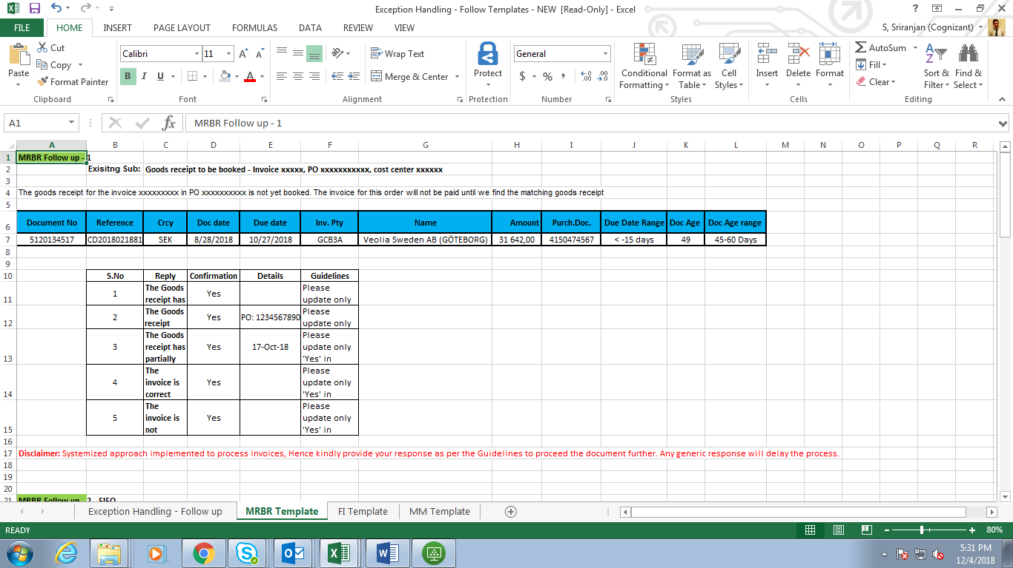

* The list of standardized email formats for MRBR follow-ups is attached in the excel



* Paste the standard mail content in the “new mail” dialog box

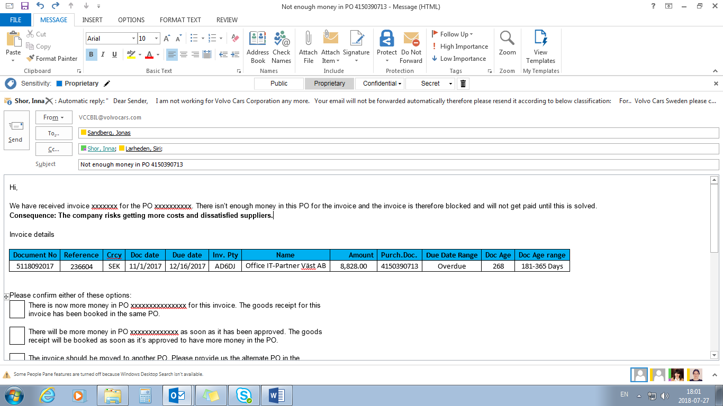

## Process of downloading & attaching the invoice copy in email:

Pre requisite for downloading the documents from SAP: The system in which download is about to happen should have PDF reader installed in it.

* Login to SAP
* Type Transaction Code – MIR4
* Copy the document number from the consolidate report or DB
* Paste the document number in the respective field in SAP
* Go to Attachment list
* Double click on the file name
* Save file in a pre-determined path in a specific file name (Document number)

This process of downloading invoices from SAP is currently done manually. There is good scope of automation on this process of downloading invoices and saving it.

* Open the predetermined path where all the invoice attachments are saved.
* Select the value from the column “Document No” in the MRBR consolidated sheet
* Search for the value in the pre-determined path

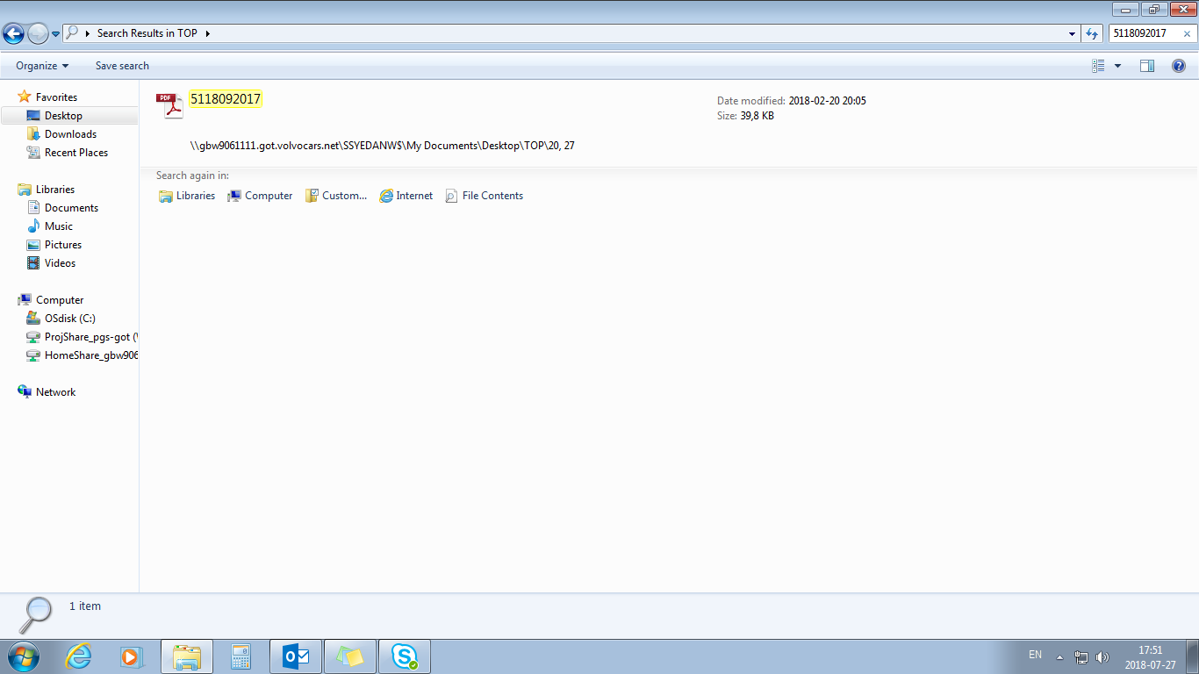

* Copy the invoice attachment that comes up in the search results
* Paste the invoice attachment in the drafted new mail

## Grouping of documents for follow-ups:

1. If the email has to be sent to the same requestor / approver for approvals and if there are multiple document for the same requestor / approver, these documents needs to be grouped and sent in a single email.
2. The attachments for the same needs to be grouped and should be sent in a ZIP format for the same requestor
3. If the line items for same requestor exceeds more than 10, it needs to be sent as an attachment in a excel format (instead of pasting the same in the body of email).

## Sending the mail to the required stakeholder

* Copy the entity from the column “Email” and paste it in the recipient dialog box
* Press “Ctrl +K” to find the mail-id for the stakeholder



* Add the standard recipients in the CC dialog box. These details will be provided by the business operations team.
* Fill in the To and CC fields
* Click on CTRL + K to verify the email recipients
* Click on Send button to send the email
* If the email gets bounced back due to requester details not available or the person would have left the company, then an email has to be sent separately to the process member IDs and lead ID’s in Cc to ensure it needs to be followed up manually.

## Updating the follow-up details in the SQL database through the VB tool

After the follow-up are sent, the values of certain fields as mentioned in this document needs to be updated in the DB. The technicalities of this is not covered in this document. This is left to the discretion of the Configurator or RPA implementation team to ensure the values gets updated in the DB properly and hence the future follow-ups happens correctly as expected.

* Open the VB tool
* Select the entity of the document number
* Select the category of the exception as MRBR Park
* Input the Document number in the “Document number” field
* Open the document
* Update the “Status” to Mail Sent
* Update the specific “Follow-up 1 field to the date on which follow-up was sent

## Mapping between DB & Report

The attached excel provides the mapping that is established between the fields that is there in the report and the fields that is present in DB.

The daily reports created needs to be updated in DB on regular basis. The mapping is established with the help of DB and analyst team.

Implementation of this is left to the discretion of the configuration/solution implementation team to arrive at a technically feasible solution.



# Exceptions

## Business Exceptions:

* All the attachments have to be downloaded and saved in a particular SharePoint directory. The bot will access the downloaded invoices through their document numbers thus, it is imperative that they have to be saved with the right name as well.
* The bot will send mails to the correct stakeholders only if the “MRBR sheet” is updated. Thus, the “MRBR sheet” should be updated before the scheduled run of the bot.
* The current mail templates need to be changed so as to allow the bots to read the reply mails from the vendors, buyers or requestors. If the bot is able to read the reply mails after standardisation, then Follow-up columns, status and clearing the invoices in the SAP can be done by the bot itself.
* The current process followed to send follow-ups is as per Doc Date range. If the doc date range exceeds 45 days, the first follow-up and subsequent follow-ups are sent. The expected or to be process for following up is with due date range. If the due date range exceeds >60 days and if the status is put as overdue, the first follow-up has to be sent. This process documented might change at any point in time due to business requirements and changes.
* The format for sending and receiving group emails (Group by requestor / Approver) is not yet finalized. This document covers of aspect of sending individual email to individual requestors / Approvers.